Ramadan Sunday 7/04/2024
Lesson 131
Merging Feature Branches
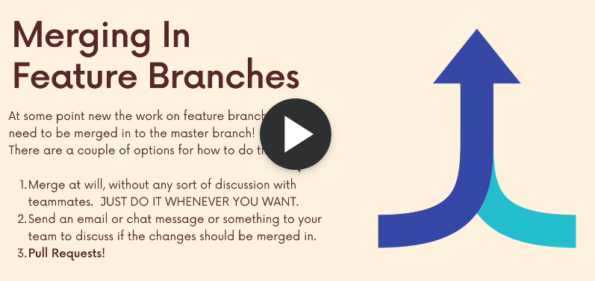
You need to confirm and talk to people before you can merge with people.
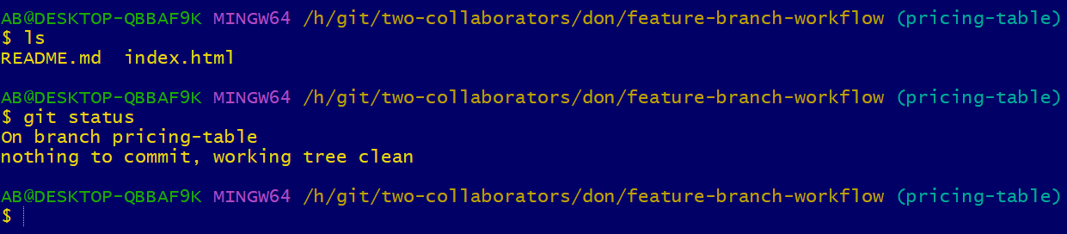
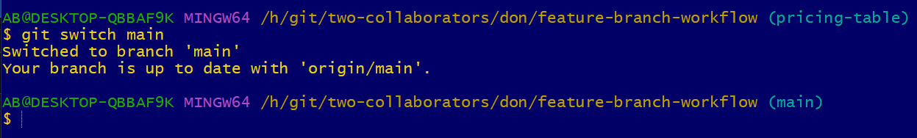
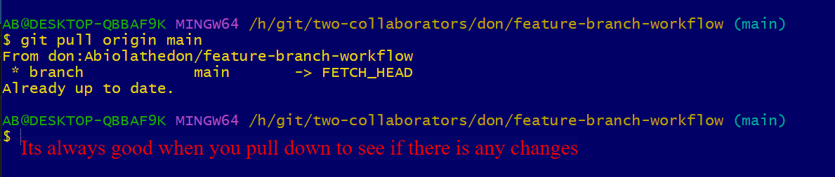
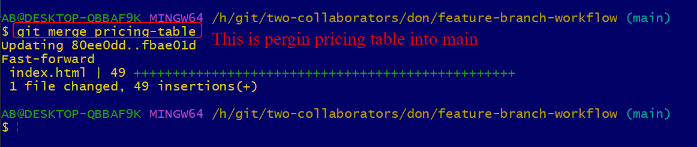
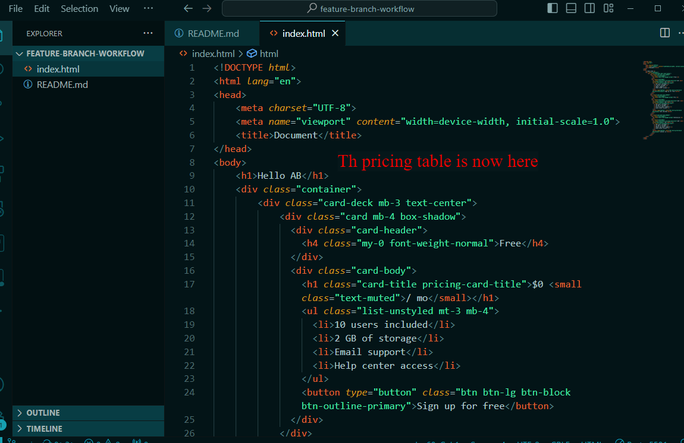
Now that I have merge now I need to push main back to the origin.
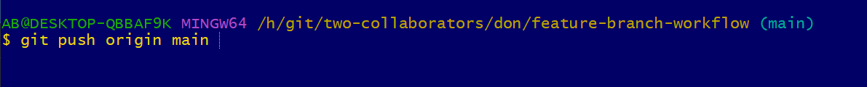
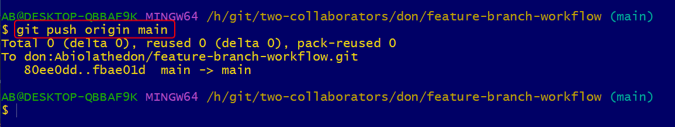
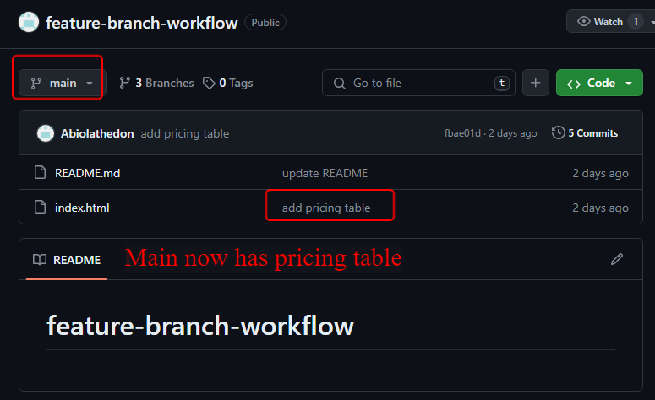
Then on the dev side He need to fetch information from the main for any changes
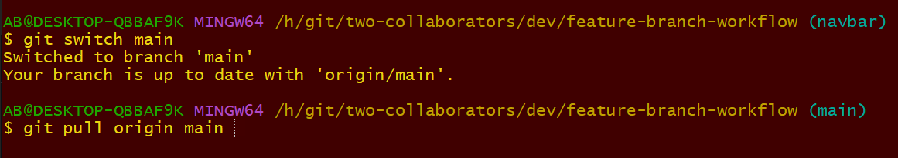
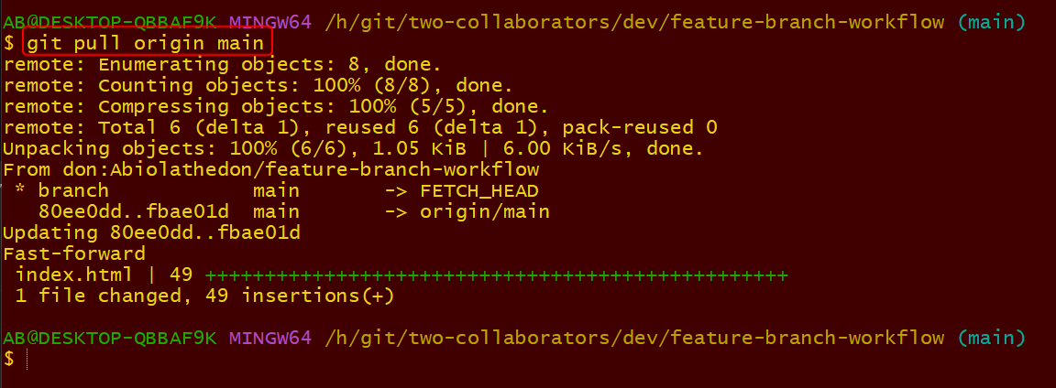
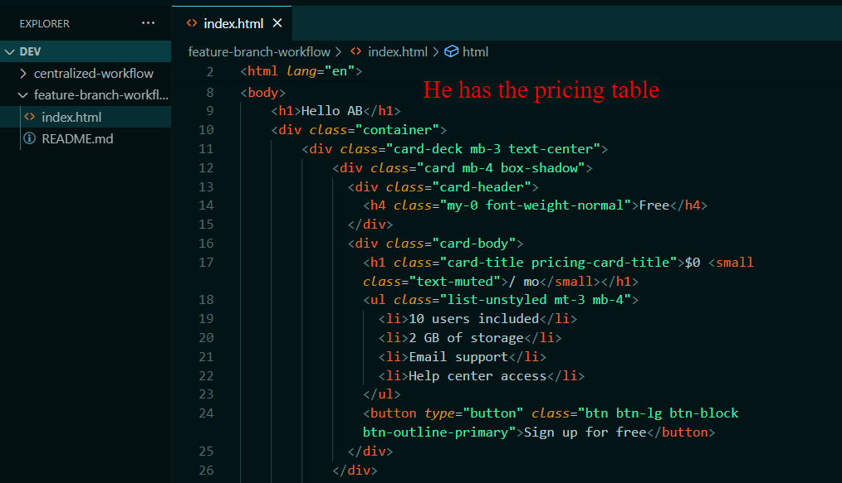
The dev also can then merge his navbar in with main. Then push to git up on main. Don can also pull it down and see the changes. And the circle continues.

